**Problem Exercise on Descriptive Epidemiology:**

**Food poisoning Outbreak Investigation in Province A,**

**Thailand, 2010**

Learning Objectives:

At the end of this exercise, participants should be able to:

- List steps in an outbreak investigation

- Describe an outbreak in time, place, and person and interpret epidemiological results and discuss some of the pitfalls in the study

- Explain how to notify and collaborate with appropriate agencies in outbreak management

- Understand key features of basic principles of disease control measures and risk communication

Instructions

This exercise is a group-self learning lesson. The exercise should be given to group participants page by page, sequentially. The participants select a group member to be a moderator to facilitate group discussions. The exercise should be finished within 150 minutes.

***International Field Epidemiology Training***

***Program-Thailand***

**Acknowledgement**

This exercise was first developed for the 2018 Introductory Epidemiology Course of International Field Epidemiology Training Program-Thailand. The program would like to express its sincere thanks to the investigator team that investigated a food poisoning outbreak caused by Vibrio parahaemolyticus in steamed salted shirmp  
in K district, C province, 25 – 27 November 2014

For the future improvement, please send your comments and suggestions to Dr.Phanthanee Thitichai, FETP-Thailand, Email: [phanthanee@gmail.com](mailto:phanthanee@gmail.com)

On 2nd November 2010, Bureau of Epidemiology (BoE) was notified of 1 Foreign and 1 Thai cholera cases from same apartment in Sub-district-K, District-M, Province A, Thailand.

**Question 1** What will you do to verify an outbreak?

On 26 November 2014, the Provincial Health Office (PHO) C received a notification from the district Health office (DHO) K that there were at least 40 cases of food poisoning visited hospital K last night (normally, only 3-4 cases of diarrhea/night) and 4 cases have been hospitalized. At least 3 cases reported having meal together. Most of them developed acute diarrhea, abdominal pain and vomiting.

You are a medical epidemiologist working at PHO. On 26 November 2014, you are on duty of outbreak verification and are notify about this event.

**Question 1A** Is this something you would investigate further? Why or why not?

**Question 1B** Do you think this is an outbreak? Why?

**Question 2** What is your plan to verify diagnosis? What additional information would you need or want?

Because there was a linkage in the cluster and the number of cases exceed expectation. The food poisoning outbreak was suspected. The provincial Surveillance and Rapid Response Team (SRRT) was assigned to investigate and control the outbreak. The team planned to interview the admitted cases, collect stools and send for testing at the laboratory.

**Question 3** What are objectives of the outbreak investigation?

To verify diagnosis and confirm the outbreak, the team interviewed ward nurses and the patients then reviewed patients’ medical records and ensured that the appropriate specimen collections and tests were done.

The team found that most of the cases had watery diarrhea and abdominal cramping. Some had nausea or vomiting. Some cases developed fever, fatigue and chill. All cases came from district K but various subdistricts. Most of the cases developed signs and symptoms on 25 November 2014. There was no mass gathering event or social event in district K during 20-25 November 2014. Some cases shared meal together but some didn’t. Most common food items before the onset were shrimp followed by fried silk worm. RSC/stool culture results were still pending.

**Question 4** When the team conduct active case finding, what is an appropriate case definition? (Give fact sheets of *Vibrio parahemolyticus*)

**Question 5.** If you were a member of the Surveillance and Rapid Response Team (SRRT) of this province and were assigned to review the situation of acute diarrheal disease and food poisoning. How will you proceed? Please explain.

From provincial surveillance data analysis, the data was shown below.

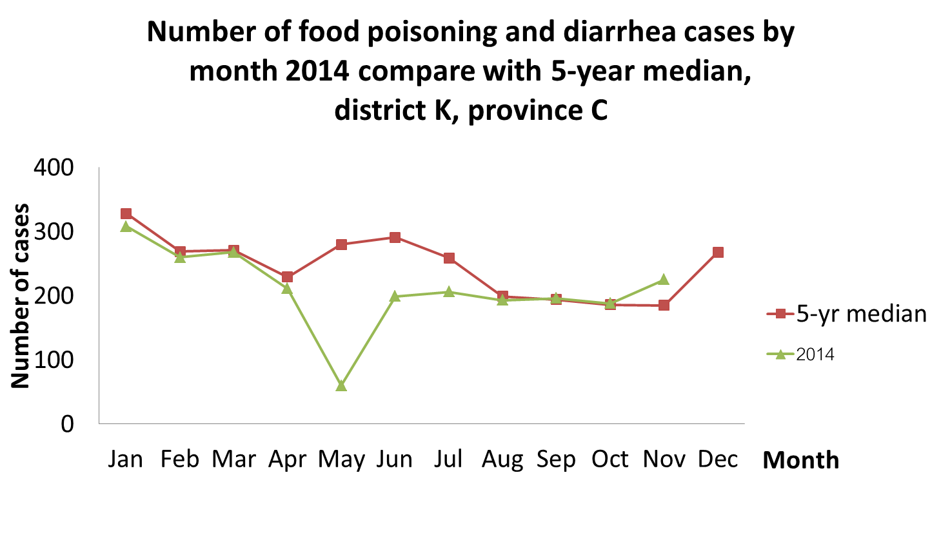

**Question 6** How will you conduct active case finding in the community?

**Question 7** What information do you need to collect in order to identify a source(s) of the outbreak? And how do you analyze and interpret information collected?

**Question 8**  Additional information and information on active case finding were given below. Please describe epidemiological characteristics of this outbreak, calculate crude attack rate, specific attack rate by subdistrict, and make an epidemic curve.

* District K is located in province C, consisted of 10 subdistricts. Total population was 73,254 people. Most of them were in agriculture sectors. Market K was centered in the district K. Water supply was provided by the District Administration Organization. The chlorination system was intact.
* Total 197 people were interviewed.
  + 99 cases had at least 3 symptoms of the following: watery or loose stool > 3 times/day, nausea/vomiting, abdominal pain, fever, fatigue, chill
  + 7 cases had RSC or stool culture result positive for Vibrio Parahaemolyticus
  + 24 cases had no culture positive but had linkages with the one who cultured positive for Vibrio Parahaemolyticus.
* From 99 cases, the mean age was 43 years, median age was 42 years, age range was 1-86 years, standard deviation (SD) of the age was 10, and interquartile range (IQR) was 22-62. Forty-five case were males. 53 cases sought treatment at a hospital (6 were admitted), 17 cases went to private clinic or pharmacy and all cases completed recovery.
  + For signs & symptoms, 94 got watery diarrhea, 79 had abdominal pain, 64 had nausea/vomiting, 49 had fatigue, 38 had fever, 23 had dry mouth/throat, 7 had headache, 2 had mucous stool and 1 had hypotension.
  + Onset time of cases

|  |  |  |  |  |
| --- | --- | --- | --- | --- |
| **time** | **24-Nov** | **25-Nov** | **26-Nov** | **27-Nov** |
| **00.01-02.00** | 0 | 0 | 2 | 0 |
| **02.01-04.00** | 0 | 0 | 0 | 0 |
| **04.01-06.00** | 0 | 0 | 1 | 0 |
| **06.01-08.00** | 0 | 0 | 0 | 0 |
| **08.01-10.00** | 0 | 1 | 0 | 0 |
| **10.01-12.00** | 0 | 6 | 0 | 0 |
| **12.01-14.00** | 0 | 17 | 0 | 0 |
| **14.01-16.00** | 0 | 16 | 0 | 0 |
| **16.01-18.00** | 0 | 24 | 0 | 0 |
| **18.01-20.00** | 0 | 7 | 1 | 0 |
| **20.01-22.00** | 0 | 2 | 0 | 0 |
| **22.01-24.00** | 0 | 0 | 0 | 0 |

**Address of all cases and total population of 10 subdistricts.**

|  |  |  |
| --- | --- | --- |
| Subdistrict | cases | population |
| TM | 3 | 6,667 |
| KYD | 10 | 3,175 |
| NK | 4 | 7,407 |
| KK | 15 | 10,417 |
| NNT | 9 | 7,826 |
| LK | 9 | 6,475 |
| NP | 1 | 6,250 |
| CSM | 8 | 6,957 |
| NS | 9 | 10,112 |
| BK | 31 | 7,969 |
| total | 99 | 73,254 |

Blank page for answer

Epidemic curve and area map of this outbreak were shown below.

Median of incubation period of this outbreak was 7 hrs. (range 1 – 36 hrs.)

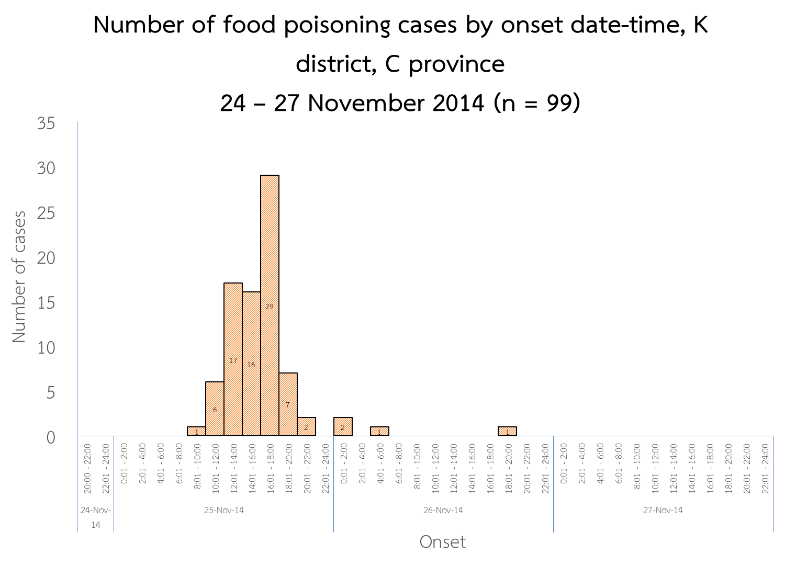

Number and attack rate of food poisoning cases by sub-district, K district, C province, 24 – 27 November 2014 (n=99)

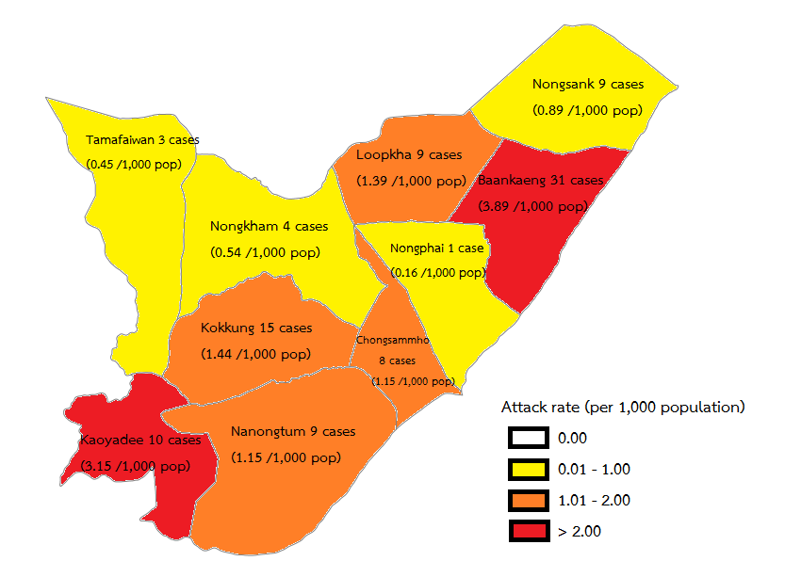

NP

BK

NS

CSM

LK

NNT

KK

NK

KYD

TM

**Question 9** The information on consumed food items of cases was shown below. Please calculate the % of eating. Which menu you suspect the most? Why?

Could we conclude the source of outbreak from this information?

|  |  |  |  |
| --- | --- | --- | --- |
| Number of cases who ate food items (n=99) | | | |
| **Food items** | **ate** | **did not eat** | **% of eating** |
| steamed salted shrimp | 82 | 17 |  |
| fried silk worm | 34 | 65 |  |
| spicy raw minced beef salad | 25 | 74 |  |
| watermelon | 22 | 77 |  |

We could not conclude that the source of outbreak was the steamed salted shrimp from this information because if the information turn out to be as the table below. The most suspicious menu will be watermelon.

|  |  |  |  |
| --- | --- | --- | --- |
| Food items | sick | Total people who consumed | %Attack rate |
| steamed salted shrimp | 82 | 500 | 16.40 |
| fried silk worm | 34 | 200 | 17.00 |
| spicy raw minced beef salad | 25 | 100 | 25.00 |
| watermelon | 22 | 50 | 44.00 |

The team was notified that results of **RSC/stool cultures from 7 patients were positive for *Vibrio Parahaemolyticus* (from total 14 patients).** The team suspected the steamed salted shrimp as a cause of outbreak and wanted to test this hypothesis.

**Question 10A**  What study design should be used to test the hypothesis? Please justify your answer. What were the case definitions would be used in the analytic study?

The team developed a questionnaire for case-control study and administered to all cases and select control from the family members, neighbors or who dined with the cases.

**Question 10**B Please calculate the odd ratio of each food items. And interpret the result.

|  |  |  |  |  |  |
| --- | --- | --- | --- | --- | --- |
| Food items | case (n=99) | | control (n=98) | |  |
| ate | did't eat | ate | did't eat | odd ratio |
| steamed salted shrimp | 82 | 17 | 11 | 87 |  |
| fried silk worm | 34 | 65 | 32 | 66 |  |
| spicy raw minced beef salad | 25 | 74 | 27 | 71 |  |
| watermelon | 25 | 74 | 52 | 46 |  |

The team favored that the steamed salted shrimp was a cause of outbreak from the case-control study. Most of patients said they bought it from the market K or food trucks. (Food truck was a grocery retailer who drives to each village to sell to villagers.) The team planned to do environmental and laboratory studies to understand the whole story of the outbreak such as how did it happen.

**Question 11** How do you conduct an environment and laboratory studies? Please describe.

Environmental study showed most of cases didn’t reheating the shrimp before eating. There was only the market K in district K which opened at 11pm – 4am and located in center of the district. There were many food trucks bought cooked foods and groceries from market K to sell in the villages. There was only one food shop sold the steamed salted shrimp in the market K. He cooked the steamed salted shrimp at his home.

At his home, there were 3 food handlers; no one was sick 3 days before and after the outbreak. Residual chlorine in consumed and tap water were 0 and 0.03 respectively.

On 24 Nov 2014,

* 10.00: bought shrimp from farm in province N and kept it in iced container
* 19.00: cooked steamed salted shrimp and kept the cooked shrimp in container
  + Cooking process
    - Washed shrimp with consumed water
    - Scoop and put each 2-kg shrimp into pot by sieve
    - Mixed with salt
    - Closed pot to steam and opened it to mix (overall around 5 mins, not exact time)
    - Scoop the shrimps with same sieve and put them into plastic bags for selling at room temperature. (normally, they separate the sieves but one sieve was just broken)

On 25 Nov, 2014,

* 01.00: Sold steamed salted shrimp at market K

The team interviewed an owner of shrimp farm found no abnormal death of shrimp before the outbreak.

Laboratory study showed

|  |  |
| --- | --- |
| **items** | **Result** |
| Stool/RSC of patients | *V. Parahaemolyticus* (7 from 14) |
| steamed salted shrimp (left over) | *V. Parahaemolyticus* (1/1) |
| RSC of food handlers | Negative* (3/3) |
| Containers | Negative* (2/2) |

*Negative: *Vibrio cholera*, *V. parahaemolyticus*, *Salmonella* spp, *Shigella* spp, *Aeromonas* spp, *Edwardsiella tarda*, *Plesiomonas* spp

PFGE was done to identified bacterial strain and found same serotypes (O3:KUT) in both patient and steamed salted shrimp. (Pulsed-field gel electrophoresis (PFGE) is a laboratory technique used by scientists to produce a DNA fingerprint for a bacterial isolate.)

**Question 12** What could be causes of *V. Parahaemolyticus* contaminated in steamed salted shrimp?

**Question 13** What recommendations would you give?

**Question 14** What should you monitor after giving the recommendations? Why?

After monitoring, there was no new case in one week.

**Question 15** Do you agree with prescribing antibiotics for all cases? (e.g. Tetracycline, Doxycycline or Norfloxacin)

*Vibrio parahaemolyticus* Fact Sheet

**What is *Vibrio parahaemolyticus*?**

*Vibrio parahaemolyticus* is a bacterium in the same family as those that cause cholera. It lives in brackish saltwater and causes gastrointestinal illness in humans. *V. parahaemolyticus* naturally inhabits coastal waters and is present in higher concentrations in warm water; it is a halophilic, or salt-requiring organism.

Temperature: Range 5-43 C, optimum 37 C. Growth is very rapid under optimum conditions

**What type of illness is caused by *V. parahaemolyticus*?**

When ingested, *V. parahaemolyticus* causes watery diarrhea often with abdominal cramping, nausea, vomiting fever and chills. Usually these symptoms occur within 24 hours of ingestion. Illness is usually self-limited and lasts 3 days. Severe disease is rare and occurs more commonly in persons with weakened immune systems. *V. parahaemolyticus* can also cause an infection of the skin when an open wound is exposed to warm seawater.

**Incubation Period**: 2-48 hours

**How does infection with *V. parahaemolyticusoccur*?**

Most people become infected by eating raw or undercooked shellfish, particularly oysters. Less commonly, this organism can cause an infection in the skin when an open wound is exposed to warm seawater.

**How common is infection with *V. parahaemolyticus*?**

In Asia, *V. parahaemolyticusis* a common cause of foodborne disease. In the United States, it is

less commonly recognized as a cause of illness, partly because clinical laboratories rarely use the selective medium that is necessary to identify this organism. Seafoods are the food group most often associated with outbreaks.

**How is *V. parahaemolyticus* treated?**

Treatment is not necessary in most cases of *V. parahaemolyticus* infection. There is no evidence that antibiotic treatment decreases the severity or the length of the illness. Patients should drink plenty of liquids to replace fluids lost through diarrhea. In severe or prolonged illnesses, antibiotics such as tetracycline, ampicillin or ciprofloxacin can be used. The choice of antibiotics should be based on antimicrobial susceptibilities of the organism.

**How is *V. parahaemolyticus* infection prevented?**

Most infections caused by *V. parahaemolyticus* in the United States can be prevented by thoroughly cooking seafood, especially oysters. Seafood should be boiled for 5 more minutes, or steamed for 9 more minutes. And if not ingested immediately, it should be refrigerated. Wound infections can be prevented by avoiding exposure of open wounds to warm seawater.

**Source:**

Alaska division of public health

www.foodsafety.gov

https://www.cdc.gov/vibrio/index.html